

**Kingdom of Saudi Arabia**

**Imam Mohammad Ibn Saud Islamic University**

**College of Computer and Information Sciences**

|  |  |
| --- | --- |
| Course | CS252/CS242 Data Structures |
| Semester | Winter 2022 |
| Instructor | Dr Abdullah Altaleb / Office 2095 |
| Email | araltaleb@imamu.edu.sa |

Course’s policies:

* **Communication:** by Email and Blackboard (Bb) only. You must include the **Course Code & Section** in the **Subject** of your message so that it is delivered to the suitable folder. Example:

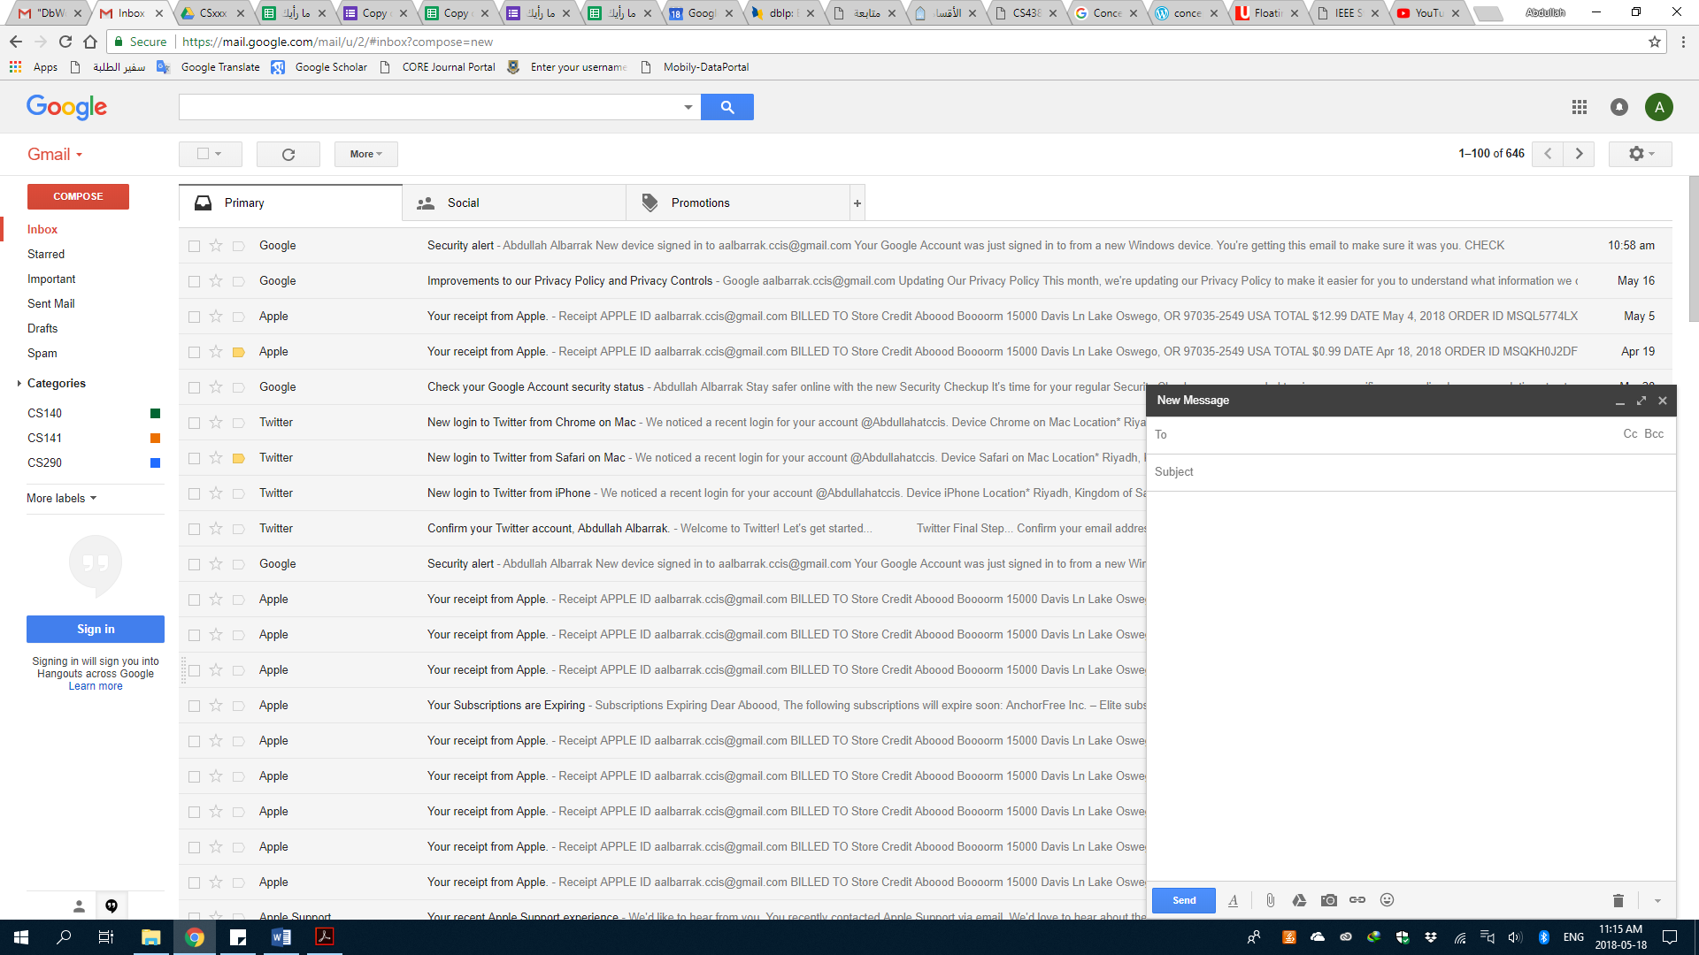

*CS252/CS242 - Section - subject*

*Email*

*your message …*

* **Announcements** are to be posted on Blackboard only. It is the student’s responsibility to:
  + Check the course’s Blackboard website for assignments and other announcements.
  + Make sure his/her student account has been added to the course’s website (Use تواصل system if you have Blackboard issue).
* **Classroom Participation:** You are expected to participate in the classroom discussion by answering questions, by asking good questions, raising issues, and making observations.
* **Penalty for Dishonesty:** Each student is expected to do his own work on all of the course material. Each person is expected to contribute equally on the class project and each team is expected to do their own work (not collaborate with others outside the team), otherwise each person involved will be subject to the University Dishonesty Policy.
* **Attendance:** Students are expected to attend all lectures. If the unjustified absence rate exceeds 20 %, the student will be denied the right to take the final exam and he/she will receive a DN grade for the course.

**TEXTBOOK**

Data Structures and Algorithms in Java, Michael T. Goodrich, Roberto Tamassia, Michael H. Goldwasser, 6th edition, Wiley, 2014, ISBN-13: 978-1118771334, ISBN-10: 1118771338.

**REFERENCES**

Mark Allen Weiss (2012), “Data Structures and Algorithm Analysis in Java (Third Edition)”.

Pat Morin (2013), “Open Data Structures (in Java)” Edition 0.1G

Grading scheme:

|  |  |  |
| --- | --- | --- |
| **Assessment type** | **Week Due** | **Percentage of Total Assessment Score** |
| Quiz | 4, 6 | 10% |
| Midterm Exam | 7 | 20% |
| Lab Exam | 9 | 15% |
| Lab Work | 1-11 | 15% |
| Final Exam | Final Week | 40% |

Course Schedule:

|  |  |  |  |
| --- | --- | --- | --- |
| Week | Date | Chapter | Notes |
| 1 | Will be Determined Later | 1. Introduction 2. Algorithm Analysis | Will be Determined Later |
| 2 | Will be Determined Later | 3- Linked List (SLL) | Will be Determined Later |
| 3 | Will be Determined Later | 3- Linked List (CLL + DLL) | Will be Determined Later |
| 4 | Will be Determined Later | 4- Stacks | Will be Determined Later |
| 5 | Will be Determined Later | 5- Queue | Will be Determined Later |
| 6 | Will be Determined Later | 6- Trees | Will be Determined Later |
| 7 | Will be Determined Later | 6- Trees | Will be Determined Later |
| 8 | Will be Determined Later | 8-Searching | Will be Determined Later |
| 9 | Will be Determined Later | 8-Searching | Will be Determined Later |
| 10 | Will be Determined Later | 9**-** HashTables | Will be Determined Later |
| 11 | Will be Determined Later | 10- Sorting | Will be Determined Later |
| 12-13 | Will be Determined Later | Finals | Will be Determined Later |

Office hours:

Contact me over email to book an arrange one-to-one meeting. You can visit me on my office at 2095 / college of computer and information sciences.